**CP Club 365 Days Challenge**

**Programming language – C++**

**Problem Statement**

<https://www.codechef.com/problems/ADJSUMPAR>

**Your Code**:

// 0x94Day of 0x365Days challenge

// VEDANT BHARAD

// 19-1-2023

#include <iostream>

using namespace std;

int main() {

    int t;

    cin>>t;

    while(t--){

        int n,sum=0;

        cin>>n;

        for(int loop=0;loop<n;loop++)

        {

            int temp;

            cin>>temp;

            sum+=temp;

        }

        if(sum%2==0)

        {

            cout<<"YES"<<endl;

        }

        else

        {

            cout<<"NO"<<endl;

        }

    }

    return 0;

}

**Output (Screen Shot)**:

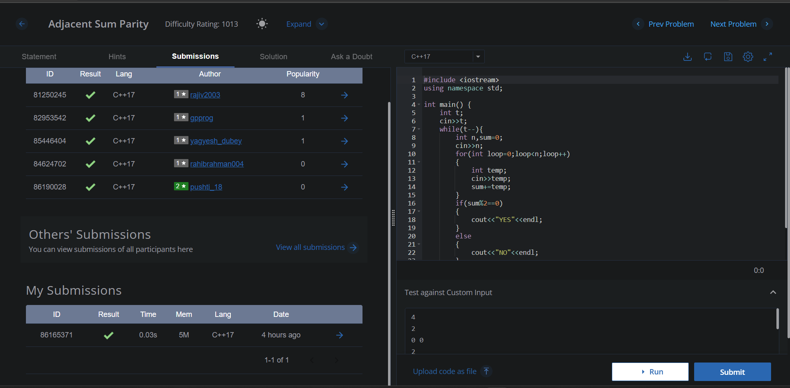

**Understanding about problem:**

In this task I need to count “1” in array and if that count in even then print “YES” else print “NO”.

Note: If you can't understand the problem, feel free to contact us and we'll help you. Please don't copy and paste from anywhere.

ALL THE BEST

Team CP Club